**RIGHT TO REPORT**

If you, or someone you know, are experiencing sexual abuse or sexual harassment, Rolette County Law Enforcement Center wants to know. We want you to report right away! Why?

* We want to keep YOU safe; it is our job! It is your right to be free from sexual abuse and sexual harassment.
* We want to conduct an investigation of the reported incident.
* We want to hold the perpetrator accountable for his/her actions.
* We want to provide YOU with relevant information and support services.

**HOW TO REPORT**

Rolette County Law Enforcement Center offers multiple ways to report sexual abuse and sexual harassment:

* Bottineau County Sheriff’s Department 701-228-2740
* Report to any staff, volunteer, contractor, or medical or mental health staff.
* Submit a grievance or sick call slip over the Turnkey messaging system.
* Tell a family member, friend, legal counsel, or anyone else outside the facility. They can report on your behalf by calling States Attorney Office: (701) 477-3169
* Report to the PREA Investigator or PREA Compliance Manager.

**VICTIM SUPPORT SERVICES**

* Family Crisis Center

606 Main Street #2

Bottineau, ND 58318

Telephone: (701) 228-2028

## **IF YOU ARE ABUSED**

Support services are available from National

Sexual Assault Hotline and can be reached at

1 (800) 656-4673 or Domestic Violence Crisis

Center (701) 852-2258

## **What to Do If You Have Been Sexually Abused**

* Tell a staff member as soon as possible.
* Seek medical attention BEFORE you shower, eat, drink, change clothing, brush your teeth, or use the bathroom.
* Share as much information as possible when answering questions to assist with the investigation.

## **NOTICE FOR FAILURE TO REPORT**

Anyone who engages in, fails to report, or knowingly condones sexual harassment or sexual abuse of an Inmate shall be subject to disciplinary action and may be subject to criminal prosecution.

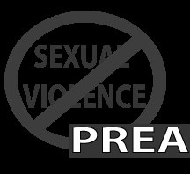

**Zero Tolerance for Sexual Abuse and Sexual Harassment: Prison Rape Elimination Act (PREA)**

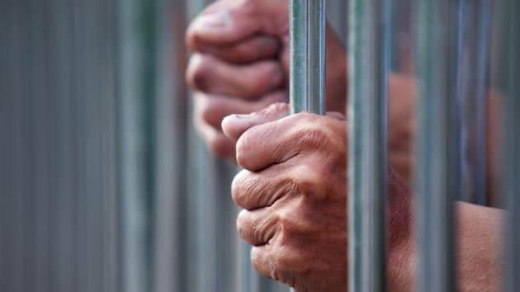

**ROLETTE COUNTY**

**LAW ENFORCEMENT CENTER**

**PREA Investigator:**

Christina Allard

(701) 477-5623

**PREA Coordinator/Compliance Manager:**

Christina Allard – Jail Administrator

(701) 477-5623

END THE

SILENCE

## **ZERO TOLERANCE**

Rolette County Law Enforcement Center has a zero-tolerance policy for sexual abuse and sexual harassment. What does this really mean? It means that **YOU** have the right to be free from sexual abuse and sexual harassment by anyone at the facility, including an Inmate, staff member, volunteer, or contractor. No one has the right to sexually abuse or sexually harass you, no one.

**What Is Sexual Harassment?**

* Repeated and unwelcome comments or gestures of a sexual nature, including demeaning references to gender, sexually suggestive or derogatory comments about body or clothing, or obscene language or gestures.
* Repeated and unwelcome sexual advances, requests for sexual favors, or verbal comments, gestures, or actions of a derogatory or offensive sexual nature.

**What Is Sexual Abuse?**

* Forced or coerced sexual intercourse or sexual contact when the victim does not consent or is unable to consent or refuse. This may include the use of fear or threat of physical violence, psychological intimidation, bullying, and physical force.
* Sexual abuse also can include incidents of penetration by a foreign object.

**What Is Staff Voyeurism?**

* An invasion of privacy of an Inmate by a staff member, contractor, or volunteer for reasons unrelated to official duties.

**Examples of Staff Voyeurism**

* Watching an Inmate use the toilet, shower, or change clothes.
* Requiring an Inmate to show their buttocks, genitals, or breasts.
* Taking pictures of an Inmates naked body or toilet use.

**Tips for Avoiding Sexual Abuse and Sexual Harassment**

A victim is never to blame for being attacked, but these tips may help you lower your risk of sexual abuse or sexual harassment.

* Pay attention to your surroundings.
* Carry yourself in a confident manner at all times.
* Do not accept gifts or favors from others. They usually come with “strings attached” or future paybacks, including sexual favors.
* Do not accept an offer from another resident to be your protector or “friend.”
* Find a staff member with whom you feel comfortable discussing your fears and concerns. Confide in him/her if you feel threatened or call RCLEC Admin at (701) 477-5623
* Be alert! Do not use contraband such as drugs or alcohol as they will weaken your ability to be alert and make good choices.
* Be direct and firm when others ask you to do things that you do not want to do.
* Do not give mixed messages to others regarding your wishes for sexual activity.
* Choose your acquaintances wisely.



Rolette County Law Enforcement Center does not tolerate any form of sexual abuse or sexual harassment. The goal of this facility is the safety of the Inmates. The facility will hold accountable any persons found to have committed any form of sexual abuse or sexual harassment against another person. If any of the information presented here is confusing, or you have questions about something that may be happening to you, ask a staff person you trust; or call (701) 477-5623.

